Capstone Project - Bank of APIs

1. Introduction
Bank of APIs is a common platform for customers to perform various banking activities such as viewing statements of accounts across different banks, transferring money between banks, and managing credit card activities. The solution will ensure security, high performance, and responsive design to work seamlessly across desktops, laptops, tablets, and mobile devices.

2. Functional Requirements
- A registered user should be able to login to the system.
- Users should be able to access any of the bank products and services like viewing statements from all accounts from multiple banks in one dashboard.
- Users should be able to transfer money from one bank account to another.
- User should be able to see his/her card(s) activities.
- Users' passwords should not be stored directly (encryption must be used).
- User should be able to edit his personal information on the profile section.

3. Non-functional Requirements
- Application should be responsive to display consistently across multiple device screens.
- Application needs to have separate front-end and back-end.
- Application needs to interact with a database for relevant data processing.
- Application should have been tested with success/failure instances.

UML Diagram
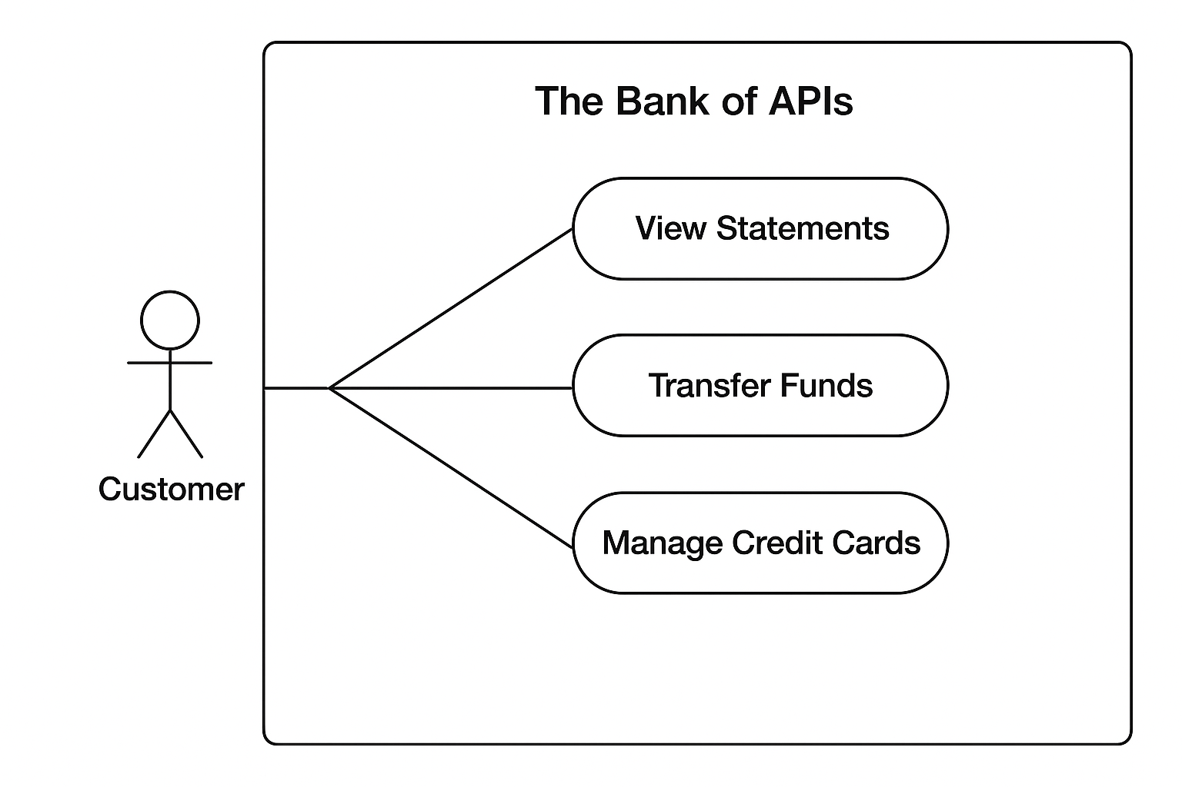

Keyscreens

Key Screens (UI Pages)

1.1 Login & Registration
Login Page: Username, password, multi-factor authentication (optional).
Registration Page: User details (name, email, phone), OTP/email verification, password setup.

1.2 Dashboard (Home Page)
Overview Widget: Consolidated account balance across all linked banks.
Quick Actions: Buttons for View Statements, Transfer Funds, Credit Card Activities.
Notifications/Alerts: Recent transactions, pending actions.

1.3 Accounts & Statements
Linked Accounts Page: List of accounts (Bank Name, Account Number, Balance).
Transaction History Page: Filterable by date, account, transaction type.
Download Statement: PDF/CSV option.

1.4 Fund Transfer
Transfer Page: Select source account, destination bank/account, amount, remarks.
Review & Confirm Page: Preview transaction, authenticate via OTP.
Transfer Status Page: Success/failure message with reference ID.

1.5 Credit Card Management
Cards Overview: All cards linked across banks, outstanding amounts, due dates.
Card Transactions: Filterable transaction list for each card.
Bill Payment: Pay credit card dues from any linked bank account.

1.6 Profile & Security
Profile Management: Update personal info, view linked accounts/cards.
Security Settings: Change password, enable 2FA, manage API tokens.

1.7 Admin Panel (Optional for Bank Admins)
User Management: View registered users, deactivate/reactivate accounts.
API Monitoring: Usage stats, errors, logs.

Front-End Flow (User Journey)
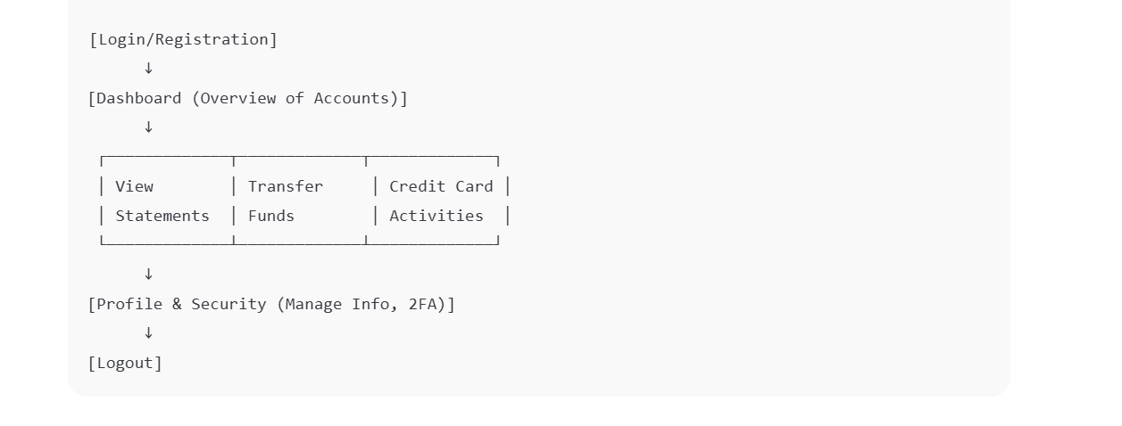

3. Front-End Tech Considerations
Framework: Angular with modular routing for each feature (/dashboard, /accounts, /transfer, /cards, /profile).
UI Library: Angular Material for consistent design & responsiveness.
State Management: NgRx or Signals for user data and API responses.
Security: JWT authentication, HTTPS, CORS configuration.
API Integration: RESTful APIs with Swagger/OpenAPI for backend interaction.

Extended API Guidelines

API Design Principles
Follow RESTful API standards with clear resource naming (e.g., /accounts/{id}/statements).
Use versioning (/api/v1/...) to ensure backward compatibility.
Support pagination, filtering, and sorting for large data sets (e.g., statements, transactions).

Authentication & Authorization
Use JWT tokens for session management and API access.
Ensure role-based access control (RBAC) for customer vs. admin operations.
Data Security & Compliance
Use HTTPS (TLS 1.2+) for all API endpoints.
Encrypt sensitive data (e.g., passwords, tokens) in transit and at rest.
Comply with banking standards (PCI DSS, GDPR).
Error Handling & Response Standards
Return standardized HTTP status codes (200, 201, 400, 401, 404, 500).
Provide detailed error messages in JSON format:
{
"code": "ERR_INVALID_ACCOUNT",
"message": "The account number provided is invalid."}
Documentation & Testing
Use Swagger/OpenAPI for interactive documentation and testing.
Provide sample requests/responses for each endpoint.
Include mock servers for frontend integration testing.
Performance & Scalability
Support rate limiting (e.g., 1000 requests/min per user).
Implement caching for frequently accessed data (e.g., account balances).
Ensure APIs are stateless for horizontal scaling.

Endpoints

1. Authentication & User Management
POST /api/auth/register # Register a new user
POST /api/auth/login # Authenticate user & return JWT token
GET /api/users/{id} # Get user profile details
PUT /api/users/{id} # Update user profile

2. Account Management
GET /api/accounts # Get all linked bank accounts for the user
GET /api/accounts/{id} # Get details of a specific account
GET /api/accounts/{id}/statements # Get account statement/transactions

3. Fund Transfers
POST /api/transfers # Initiate fund transfer between accounts
GET /api/transfers/{id} # Get details/status of a transfer
GET /api/transfers # List all transfers for a user

4. Credit Card Management
GET /api/cards # Get all credit cards linked to user
GET /api/cards/{id} # Get specific credit card details
GET /api/cards/{id}/transactions # Get credit card transaction history

5. Admin (Optional)
GET /api/admin/users # View all users (Admin only)
GET /api/admin/logs # View system logs (Admin only)

Security
All endpoints (except /auth/register and /auth/login) should require JWT token authentication.
Sensitive data (passwords, card numbers) should be encrypted.

6. Tools and Technologies
- Front End: Angular
- Back End: Spring Boot with Microservices Patterns
- Database: MySQL, PostgreSQL & MongoDB
- Testing: Postman, Swagger, Mockito, JUnit5, Karma

Entites & Relationships
Entity | Attributes (Key Fields) | Relationships
Customer | CustomerID (PK), Name, Email, Phone, Address, PasswordHash, DateOfBirth | 1:N with Account, 1:N with CreditCard, 1:N with Transaction
Bank | BankID (PK), BankName, BranchCode, IFSCCode, Address | 1:N with Account
Account | AccountID (PK), AccountNumber, AccountType (Savings/Current), Balance, Status, CustomerID (FK), BankID (FK) | 1:N with Transaction, N:1 with Customer, N:1 with Bank
Transaction | TransactionID (PK), Amount, TransactionType (Credit/Debit/Transfer), Date, Status, AccountID (FK), ToAccountID(FK) | N:1 with Account, 1:1 optional to Transfer
Transfer | TransferID (PK), FromAccountID (FK), ToAccountID (FK), Amount, TransferDate, Status | N:1 with Transaction
CreditCard | CardID (PK), CardNumber, ExpiryDate, CVV (encrypted), Limit, Status, CustomerID (FK) | 1:N with CardTransaction, N:1 with Customer
CardTransaction | CardTxnID (PK), CardID (FK), Amount, Merchant, Date, Status | N:1 with CreditCard
UserLoginLog | LogID (PK), CustomerID (FK), LoginTime, IPAddress | N:1 with Customer

Key Relationships
Customer – Account: One customer can have multiple accounts across multiple banks.
Bank – Account: Each account belongs to one bank, but a bank can have multiple accounts.
Account – Transaction: Each account can have multiple transactions.
Account – Transfer: Transfers involve two accounts (From and To).
Customer – CreditCard: One customer can have multiple credit cards.
CreditCard – CardTransaction: Each credit card can have multiple card transactions.
Customer – UserLoginLog: Each login attempt is recorded for security.

UX Guidelines Table with Implementation for The Bank of APIs platform:

UX Guidelines & Implementation Table
UX Guideline | Description | Implementation in Bank of APIs
Responsive Design | Ensure the application works seamlessly across all devices and screen sizes. | Use Angular Flex Layout or CSS Grid/Flexbox to create adaptive dashboards for mobile, tablet, and desktop.
Intuitive Navigation | Provide a clear and simple navigation structure for easy access to features. | Implement a side navigation menu with clear sections like Accounts, Transfers, Credit Cards.
Consistency in UI | Maintain uniform styling, color schemes, and component behavior. | Use Angular Material for consistent design patterns (buttons, dialogs, forms).
Accessibility (WCAG) | Ensure the platform is accessible to users with disabilities. | Add ARIA labels, keyboard navigation support, and color contrast compliance.
User Feedback & Alerts | Provide immediate feedback for actions (success, error, loading). | Use Snackbars, Toasts, and Loading Spinners in Angular Material for feedback on actions like transfers or updates.
Security Indicators | Give users confidence that their data and transactions are secure. | Display SSL lock icons, show session timeout warnings, and use masked account numbers.
Minimal Cognitive Load | Avoid overwhelming users with too much data on one screen. | Use tabs and collapsible panels for account details and transaction history.
Error Prevention | Minimize errors and guide users when they occur. | Provide form validations, pre-filled fields, inline error messages, and confirmation dialogs before transactions.
Personalization | Tailor user experience based on preferences and usage patterns. | Show personalized dashboards (frequent accounts, last transactions) and allow custom settings.

General Guidelines
Project Structure
◦ Maintain a consistent folder structure for frontend, backend, and documentation.
◦ Separate configuration files, source code, and assets for clarity.
Coding Standards
◦Use meaningful variable, function, and class names.
◦Maintain consistent indentation, spacing, and commenting.
Version Control with Git
◦Repository Setup: Initialize a Git repository at the project root (git init).
Branching Strategy:
▪ Use main (or master) for production-ready code.
▪ Create feature branches (feature/<feature-name>) for new features.
Documentation
◦Keep API specs, UI/UX guidelines, and system diagrams updated.
◦Include README with project setup, dependencies, and instructions.
Testing & Validation
◦Test features before committing.
◦Document test cases and outcomes for major modules.

